

CAP455 – OBJECT-ORIENTED PROGRAMMING USING C++

MINOR PROJECT – CA1 REPORT

Volunteer Skill Directory and Task Matcher

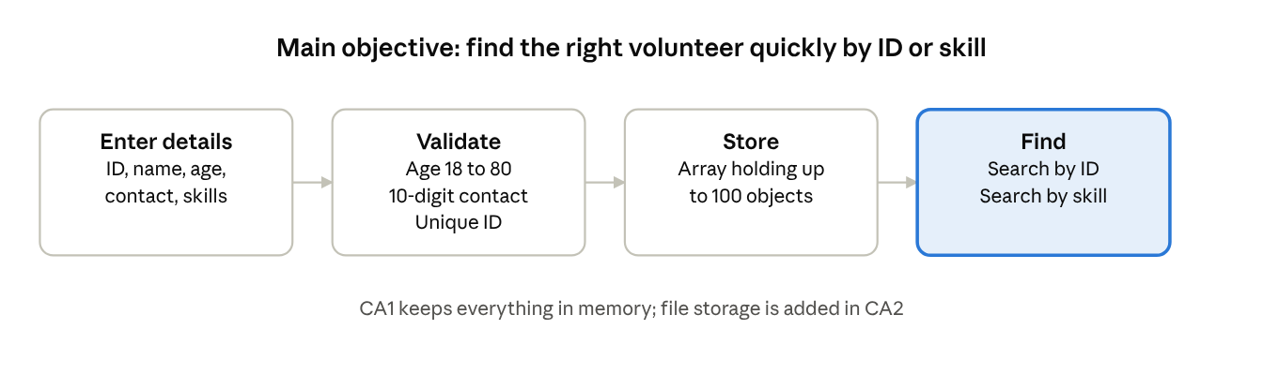

DETAILS
Field | Detail
Course | CAP455: Object-Oriented Programming using C++
Phase | CA1
Project title | Volunteer Skill Directory and Task Matcher
Student name | Mrigendra Singh
Roll number | 68
Registration Number | 12612199
Git Link
Faculty | Adarsh Singh

Declaration

I Mrigendra singh, Roll Number 68, a student of MCA, declare that this CA1 report and the accompanying C++ program for the Volunteer Skill Directory and task matching (CAP455, Object-Oriented Programming using C++) are my own work. I understand the design, the source code and the test cases, and I can explain and modify any part of them during the viva.
Where I used books, online references or AI tools, I have stated this below, and I have not copied work from other students or presented someone else's work as mine.

Signature: Mrigendra singh

Date: 05-11-26

Acknowledgement
I express my sincere gratitude to my course faculty, Mr. Adarsh Singh, for the guidance and support extended during the development of this CA1 project. I also acknowledge the learning resources and programming tools that helped me understand the C++ concepts, design the program and prepare this documentation.

Table of contents
- 1. Problem statement and objectives…………………………………………………………3
- 2. Data dictionary…………………………………………………………………………………….…3
- 3. UML class diagram………………………………………………………………………………….4
- 4. Flowcharts………………………………………………………………………………………………5
- 5. Implementation of CA1 concepts……………………………………………….……..……7
- 6. Source code……………………………………………………………………………………………8
- 7. Sample run……………………………………………………………………………………………11
- 8. Test cases……………………………………………………………………………………………..14
- 9. Limitations and plan for CA2, CA3 and CA4…………………………………………..15
- 10.Conclusion…………………………………………………………………………………………..15

1. Problem statement and objectives
NGOs and community groups keep volunteer details in notebooks or scattered sheets, so finding someone with a needed skill is slow and records are often duplicated or incomplete. The Volunteer Skill Directory is a C++ console application that stores volunteer records in memory, validates every entry, and lets an organiser find volunteers by ID or by skill.
CA1 delivers the Create and Read parts of the project. Records live in memory only; file storage is planned for CA2.

2. Data dictionary
The Volunteer class has five data members plus one static counter. All are private.
Attribute | C++ type | Size / range | Constraint | Validation in code
volunteerId | int | positive | Unique primary key | Must be greater than 0; duplicate IDs rejected in main()
name | std::string | variable | Required | Read with getline; must not be empty
age | int | 18 to 80 | Required | Loop re-asks until in range; non-numeric input is cleared
contact | std::string | exactly 10 characters | Digits only | Loop re-asks until length is 10 and all characters are 0-9
skills | std::string | variable | Required, comma separated | Read with getline; must not be empty
totalVolunteers | static int | 0 upward | Class-level counter | Incremented only after a successful add

3. UML class diagram
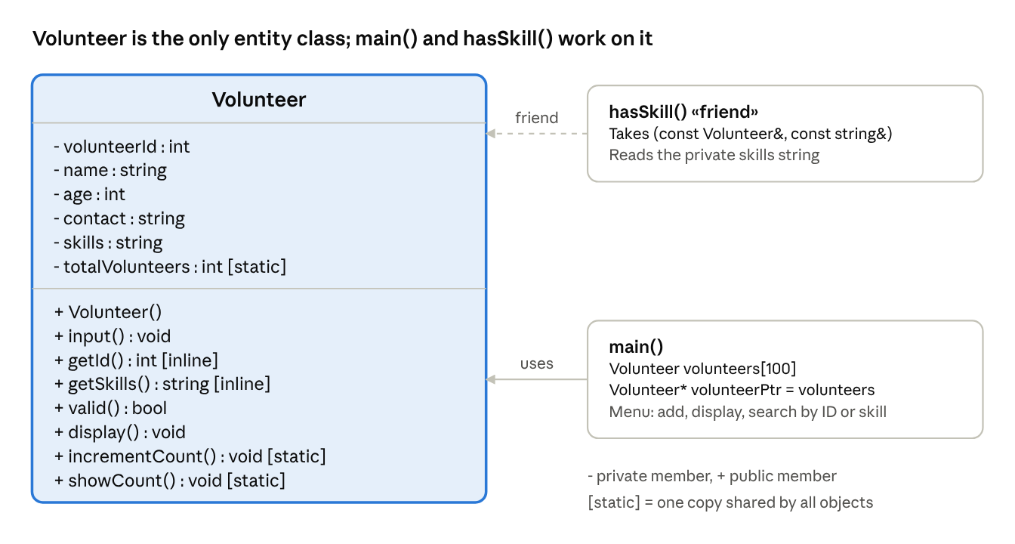

4. Flowcharts
Flowchart 1: main menu. The program shows the menu, reads a choice and runs the matching action until the user enters 0.
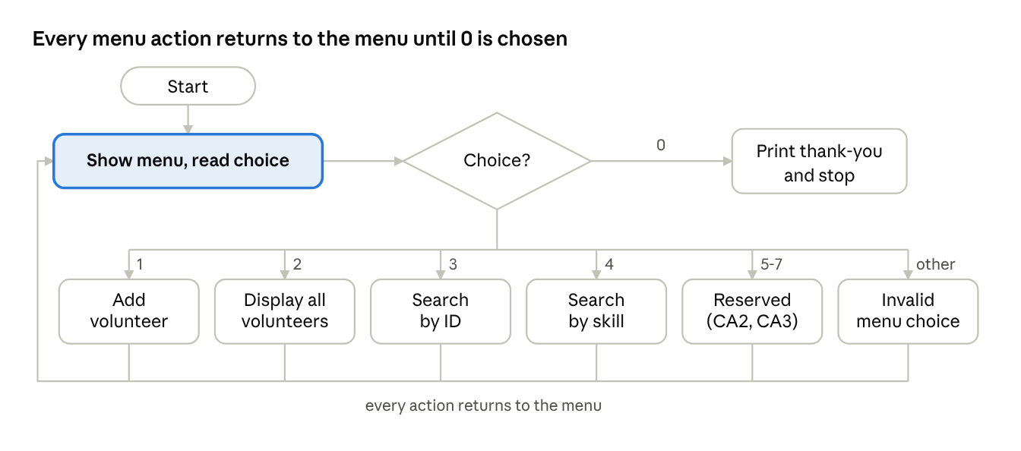
Flowchart 2: Add Volunteer. Age and contact are re-asked until valid, while an invalid record or a duplicate ID is rejected after input and nothing is stored.
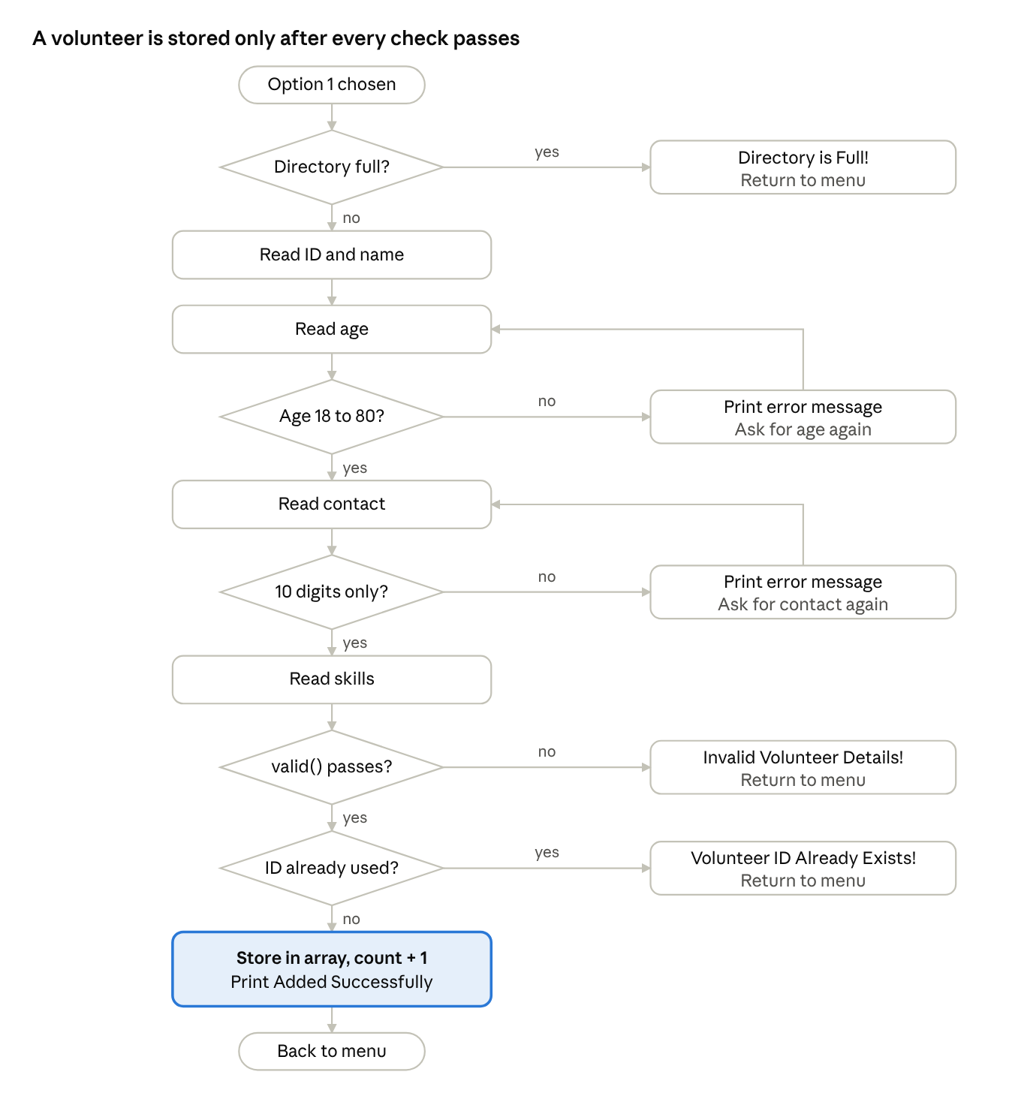
Flowchart 3: Display All Volunteers (option 2). An empty directory prints a message; the total is always shown at the end.
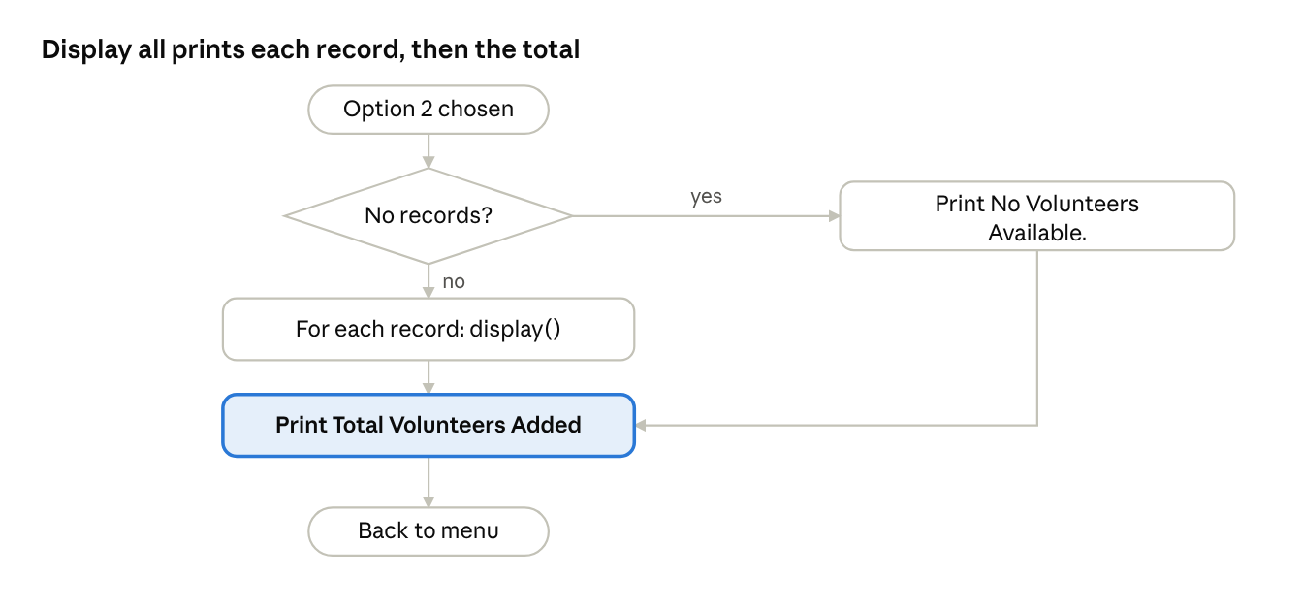
Flowchart 4: Search by ID (option 3). The search stops at the first matching ID.
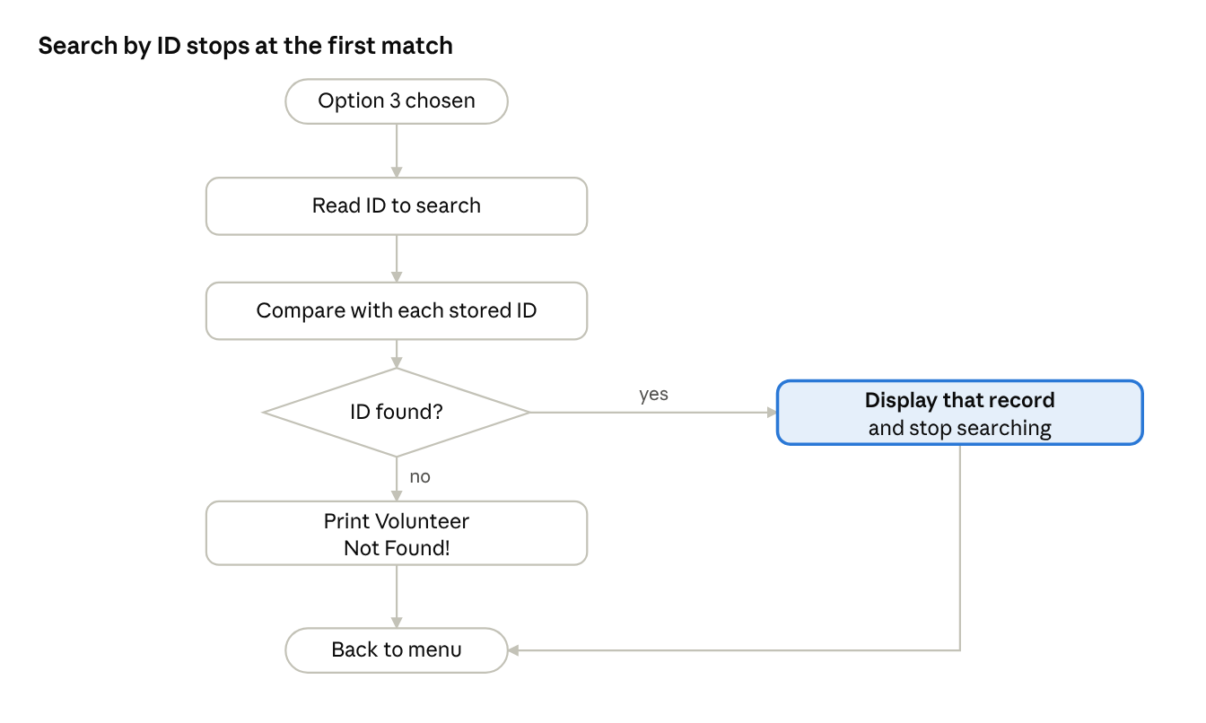
Flowchart 5: Search by Skill (option 4). Every volunteer whose skills contain the text is shown; a message appears only when none match.
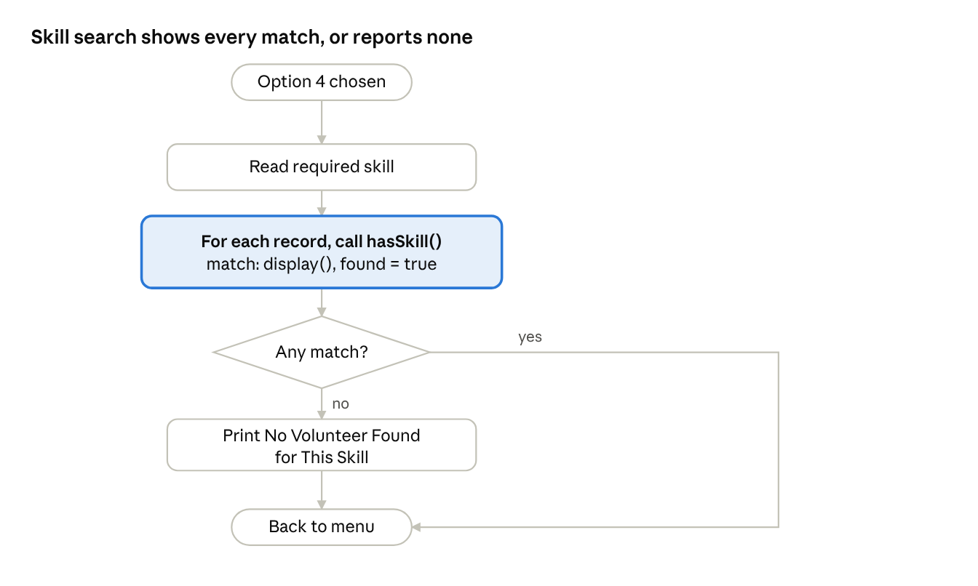
Flowchart 6: Options 5, 6 and 7. These choices only print a message that the feature is reserved for CA2 or CA3.
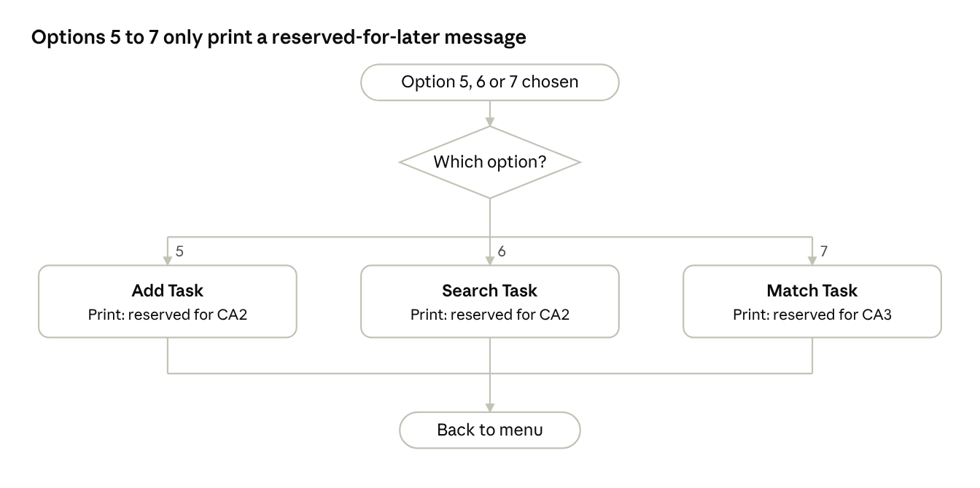

5. Implementation of CA1 concepts
Every Unit I-II feature required for CA1 appears in the source code, as mapped below.
Concept | Where used | Why
Encapsulation | All Volunteer data members are private; access is through methods | Stops outside code from storing invalid values directly
Static data member | totalVolunteers, defined outside the class as 0 | One shared count for all objects
Static member functions | incrementCount(), showCount() | Update and print the counter without needing an object
Inline functions | getId(), getSkills() declared inline | Small getters used inside loops
Friend function | hasSkill(const Volunteer&, const string&) | Reads the private skills string for skill search
this pointer | Used in input() when assigning volunteerId, name, contact, skills | Makes it explicit that members of the current object are being set
Array of objects | Volunteer volunteers[MAX_VOLUNTEERS] in main() | Fixed-size in-memory store for 100 records
Pointer to objects | Volunteer* volunteerPtr = volunteers; accessed as volunteerPtr[i] | Traverses the array for display, ID search, skill search and duplicate check
std::string | name, contact, skills, plus find() and find_first_not_of() | Safe text handling and digit validation
Constant correctness | const member functions: valid(), display(), getId(), getSkills() | Guarantees these functions do not change the object
Default constructor | Volunteer() sets volunteerId and age to 0 | Gives array elements a known starting state

6. Source code
#include <iostream>
#include <string>
using namespace std;
const int MAX_VOLUNTEERS = 100; // Limits for number of volunteers
class Volunteer {
private:
int volunteerId;
string name;
int age;
string contact;
string skills;
static int totalVolunteers;
public:
Volunteer() : volunteerId(0), age(0) {}
void input() {
cout << "\nEnter Volunteer ID: ";
cin >> this->volunteerId;
cout << "Enter Full Name: ";
cin >> ws;
getline(cin, this->name);
// Age validation
do {
cout << "Enter Age (18-80): ";
cin >> age;
if (cin.fail()) {
cout << "Invalid input! Enter numbers only.\n";
cin.clear();
cin.ignore(1000, '\n');
age = 0;
}
else if (age < 18 || age > 80) {
cout << "Age must be between 18 and 80.\n";
}
} while (age < 18 || age > 80);
// Contact validation
cout << "Enter Contact (10 digits): ";
cin >> this->contact;
while (contact.length() != 10 ||
contact.find_first_not_of("0123456789") != string::npos) {
cout << "Invalid contact! Enter exactly 10 digits.\n";
cout << "Enter Contact (10 digits): ";
cin >> this->contact;
}
cout << "Enter Skills (comma separated): ";
cin >> ws;
getline(cin, this->skills);
}
inline int getId() const {
return volunteerId;
}
inline string getSkills() const {
return skills;
}
bool valid() const {
return volunteerId > 0 &&
age >= 18 && age <= 80 &&
!name.empty() &&
contact.length() == 10 &&
contact.find_first_not_of("0123456789") == string::npos &&
!skills.empty();
}
void display() const {
cout << "\nVolunteer ID: " << volunteerId
<< "\nName: " << name
<< "\nAge: " << age
<< "\nContact: " << contact
<< "\nSkills: " << skills << "\n";
}
static void incrementCount() {
++totalVolunteers;
}
static void showCount() {
cout << "\nTotal Volunteers Added: "
<< totalVolunteers << "\n";
}
friend bool hasSkill(const Volunteer&, const string&);
};
int Volunteer::totalVolunteers = 0;
// Friend Function
bool hasSkill(const Volunteer& volunteer, const string& skill) {
return volunteer.skills.find(skill) != string::npos;
}
// Main Function
int main() {
Volunteer volunteers[MAX_VOLUNTEERS];
Volunteer* volunteerPtr = volunteers;
int volunteerCount = 0;
int choice;
do {
cout << "\n----- VOLUNTEER SKILL DIRECTORY------ ";
cout << "\n1. Add Volunteer";
cout << "\n2. Display All Volunteers";
cout << "\n3. Search Volunteer by ID";
cout << "\n4. Search Volunteer by Skill";
cout << "\n5. Add Task";
cout << "\n6. Search Task";
cout << "\n7. Match Task with Volunteers";
cout << "\n0. Exit";
cout << "\n\nEnter Choice: ";
cin >> choice;
// Add Volunteer
if (choice == 1) {
if (volunteerCount >= MAX_VOLUNTEERS) {
cout << "\nVolunteer Directory is Full!\n";
continue;
}
Volunteer temp;
temp.input();
bool duplicate = false;
for (int i = 0; i < volunteerCount; ++i) {
if (volunteerPtr[i].getId() == temp.getId()) {
duplicate = true;
break;
}
}
if (!temp.valid()) {
cout << "\nInvalid Volunteer Details!\n";
}
else if (duplicate) {
cout << "\nVolunteer ID Already Exists!\n";
}
else {
volunteers[volunteerCount] = temp;
++volunteerCount;
Volunteer::incrementCount();
cout << "\nVolunteer Added Successfully!\n";
}
}
// Display All Volunteers
else if (choice == 2) {
if (volunteerCount == 0) {
cout << "\nNo Volunteers Available.\n";
}
for (int i = 0; i < volunteerCount; ++i) {
volunteerPtr[i].display();
}
Volunteer::showCount();
}
// Search Volunteer by ID
else if (choice == 3) {
int id;
cout << "\nEnter Volunteer ID: ";
cin >> id;
bool found = false;
for (int i = 0; i < volunteerCount; ++i) {
if (volunteerPtr[i].getId() == id) {
volunteerPtr[i].display();
found = true;
break;
}
}
if (!found) {
cout << "\nVolunteer Not Found!\n";
}
}
// Search Volunteer by Skill
else if (choice == 4) {
string skill;
cout << "\nEnter Required Skill: ";
cin >> ws;
getline(cin, skill);
bool found = false;
for (int i = 0; i < volunteerCount; ++i) {
if (hasSkill(volunteerPtr[i], skill)) {
volunteerPtr[i].display();
found = true;
}
}
if (!found) {
cout << "\nNo Volunteer Found for This Skill.\n";
}
}
// Add Task - Future CA
else if (choice == 5) {
cout << "\n ADD TASK:";
cout << "\nThis feature is reserved for CA2.";
cout << "\nTask creation and file storage will be";
cout << "\nimplemented in the next phase.\n";
}
// Search Task - Future CA
else if (choice == 6) {
cout << "\n SEARCH TASK:";
cout << "\nThis feature is reserved for CA2.";
cout << "\nTask searching and record retrieval will be";
cout << "\nimplemented in the next phase.\n";
}
// Match Task - Future CA
else if (choice == 7) {
cout << "\n MATCH TASK WITH VOLUNTEERS:";
cout << "\nThis feature is reserved for CA3.";
cout << "\nAdvanced task matching using inheritance";
cout << "\nand polymorphism will be implemented";
cout << "\nin a future phase.\n";
}
// Invalid Choice
else if (choice != 0) {
cout << "\nInvalid Menu Choice!\n";
}
} while (choice != 0);
cout << "\nThank You for Using Volunteer Skill Directory!\n";
return 0;
}

7. Sample run
Code run for all the given options:
----- VOLUNTEER SKILL DIRECTORY------
1. Add Volunteer
2. Display All Volunteers
3. Search Volunteer by ID
4. Search Volunteer by Skill
5. Add Task
6. Search Task
7. Match Task with Volunteers
0. Exit
Enter Choice: 1
Enter Volunteer ID: 101
Enter Full Name: Asha Verma
Enter Age (18-80): 17
Age must be between 18 and 80.
Enter Age (18-80): abc
Invalid input! Enter numbers only.
Enter Age (18-80): 25
Enter Contact (10 digits): 98765
Invalid contact! Enter exactly 10 digits.
Enter Contact (10 digits): 9876543210
Enter Skills (comma separated): First Aid, Driving
Volunteer Added Successfully!
----- VOLUNTEER SKILL DIRECTORY------
1. Add Volunteer
2. Display All Volunteers
3. Search Volunteer by ID
4. Search Volunteer by Skill
5. Add Task
6. Search Task
7. Match Task with Volunteers
0. Exit
Enter Choice: 2
Volunteer ID: 101
Name: Asha Verma
Age: 25
Contact: 9876543210
Skills: First Aid, Driving
Total Volunteers Added: 1
----- VOLUNTEER SKILL DIRECTORY------
1. Add Volunteer
2. Display All Volunteers
3. Search Volunteer by ID
4. Search Volunteer by Skill
5. Add Task
6. Search Task
7. Match Task with Volunteers
0. Exit
Enter Choice: 3
Enter Volunteer ID: 101
Volunteer ID: 101
Name: Asha Verma
Age: 25
Contact: 9876543210
Skills: First Aid, Driving
Volunteer Not Found!
----- VOLUNTEER SKILL DIRECTORY------
1. Add Volunteer
2. Display All Volunteers
3. Search Volunteer by ID
4. Search Volunteer by Skill
5. Add Task
6. Search Task
7. Match Task with Volunteers
0. Exit
Enter Choice: 4
Enter Required Skill: Driving
Volunteer ID: 101
Name: Asha Verma
Age: 25
Contact: 9876543210
Skills: First Aid, Driving
----- VOLUNTEER SKILL DIRECTORY------
1. Add Volunteer
2. Display All Volunteers
3. Search Volunteer by ID
4. Search Volunteer by Skill
5. Add Task
6. Search Task
7. Match Task with Volunteers
0. Exit
Enter Choice: 5
ADD TASK:
This feature is reserved for CA2.
Task creation and file storage will be
implemented in the next phase.
----- VOLUNTEER SKILL DIRECTORY------
1. Add Volunteer
2. Display All Volunteers
3. Search Volunteer by ID
4. Search Volunteer by Skill
5. Add Task
6. Search Task
7. Match Task with Volunteers
0. Exit
Enter Choice: 0
Thank You for Using Volunteer Skill Directory!

8. Test cases
Expected results below are taken from reading the code. Run each case, then record what you observed in the last column (Pass or Fail) before submitting.
# | Type | Feature | Input | Expected result
1 | Normal | Add | Input Required data | "Volunteer Added Successfully!"; count becomes 1
2 | Boundary | Age | 18>Age<80 | Accepted
3 | Invalid | Contact | 98765 (5 digits) | "Invalid contact! Enter exactly 10 digits."; asks again
4 | Invalid | Add | ID 0 or -5 | "Invalid Volunteer Details!"; record not stored
5 | Invalid | Add | ID 101 entered a second time | "Volunteer ID Already Exists!"; record not stored
6 | Boundary | Capacity | Add a 101st volunteer | "Volunteer Directory is Full!"
7 | Normal | Display | Option 2 with 2 records | Both records shown, then "Total Volunteers Added: 2"
8 | Boundary | Display | Option 2 with no records | "No Volunteers Available." then total 0
9 | Normal | Search by ID | Existing ID | That volunteer is displayed
10 | Invalid | Search by ID | ID not in directory | "Volunteer Not Found!"
17 | Normal | Search by skill | Driving | Every volunteer whose skills contain "Driving" is shown
12 | Invalid | Search by skill | Plumbing (no match) | "No Volunteer Found for This Skill."
13 | Invalid | Menu | 9 | "Invalid Menu Choice!"
14 | Normal | Menu | 5, 6, 7 | Message that the feature is reserved for CA2 or CA3
15 | Normal | Menu | 0 | "Thank You for Using Volunteer Skill Directory!" and exit

9. Limitations and plan for CA2, CA3 and CA4
These are known gaps in the CA1 version, listed so they can be fixed in later phases.
- No persistence. All records are lost when the program exits. CA2 adds fstream binary fixed-size records.
- Menu and ID input are not checked for non-numeric text. Typing letters at the menu sets the choice to 0 and exits the program; letters at an ID prompt leave the input stream in a failed state. CA4 handles this with try/catch/throw and a custom exception class.
- Skill search is case-sensitive and substring-based. Searching "first aid" will not match "First Aid", and a short term like "C" can match unrelated skills. CA4 can use STL find_if and count_if for cleaner searching.
- Late validation of the ID. An ID of 0 or a duplicate is reported only after every field has been typed in.
- Fixed capacity. The array holds 100 records; dynamic memory comes in CA3 and STL vector or list in CA4.
- Unused code. getSkills() is defined but not called.
- No update or delete yet. Update (seekp) arrives in CA2 and safe Update and Delete in CA3, and the full CRUD menu in CA4. There is also no backup or export yet, which CA4 covers with an advanced feature.
Next phases
Phase | Planned work
CA2 | Parameterised and copy constructors, destructor, binary file storage, search with seekg, basic update with seekp, Task entity
CA3 | Base class and at least two derived classes, operator overloading, type conversion, new/delete, virtual functions and destructor, safe Update and Delete, task matching
CA4 | Custom exception class with try/catch/throw, function and class templates, STL vector or list with sort, find_if and count_if, full CRUD menu, at least one advanced feature (backup, CSV export or undo), project report and live demo

10. Conclusion
CA1 delivers the Create and Read parts of the Volunteer Skill Directory and Task Matcher. A working console program stores up to 100 volunteer records in an array of Volunteer objects, rejects invalid ages, contact numbers and duplicate IDs, and lets the user display all records or search by ID or by skill. The design is documented with a data dictionary, a UML class diagram and flowcharts, and the sample run in section 9 shows the real program output.

